
ANNUAL POST DATA REPORT
2027 Membership Year
AMERICAN LEGION POST District Data as of 1/8/2026

Post’s Legal Name (as shown on Post Charter): Post Location (as shown on Post Charter):

(Contact your Department Headquarters immediately if any of the information above is incorrect.)
Please type or print in ink and forward to the Department by April 15, 2026

CURRENTLY ON FILE: CHANGE OR CORRECTION:

1) Post’s Home (Physical) Address: _________________________________________
_________________________________________
_________________________________________

2) Post’s Mailing Address: |  |  |  |  |  | _________________________________________  _________________________________________  _________________________________________

3) Post’s Dues Mailing Address: ___________________________________________
___________________________________________
___________________________________________
Note: If the above address contains a member’s name or is
Being Sent to a member’s home address as the contact, please provide The member’s ID:

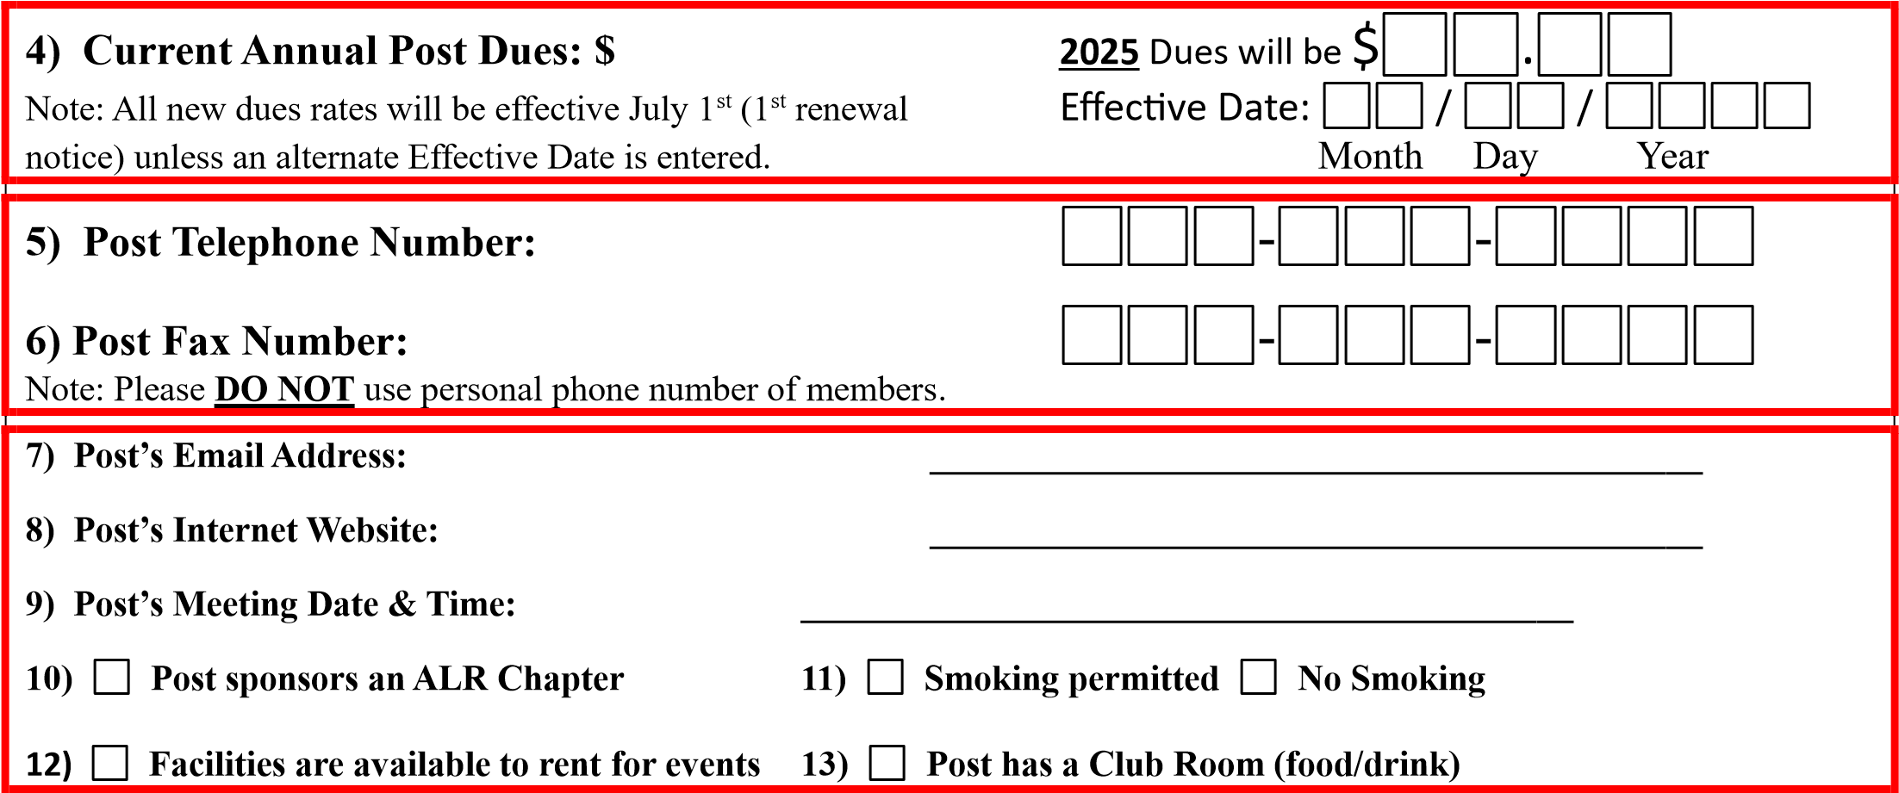

__________________________________________ _________________________________________
Post Adjutant or Commander Signature Date

IMPORTANT NOTICE
Complete and return this form to your Department Headquarters no later than April 12, 2026. Failure to meet this deadline may cause the first 2027 Renewal Notices to be mailed with incorrect information.
(Detailed instructions on the reverse side)
Instructions
Throughout the year National must contact its Posts regarding membership renewals, awards, Veterans Affairs, or other important information. In addition, National receives daily requests for Post information from members and potential new members, or others who are looking for information about The American Legion at the local level. Maintaining current Post information on National’s files has become more important than ever.
The Annual Post Data Report is used by the Post to inform the Department and National Headquarters of pertinent information regarding the local Post and, most importantly, membership renewal information. The left column (CURRENTLY ON FILE) shows the information that National has on record for the Post. Updates to the information should be entered in the right column (CHANGE OR CORRECTION). Instructions or a description of each item are shown below.
This information will be maintained on the National records and, with Department approval, may be published on its websites (legion.org or myLegion.org) through its Post Locator feature.
Please remember to inform your Department Headquarters anytime a change is made throughout the year.

- Enter the actual physical location of the Post home. This may be a structure owned by the Legion Post or it could be a location shared with another business or organization. For example, the Post may meet regularly at a banquet facility; it may or may not be the Post’s mailing address.
- Enter the regular mailing address of the Post. This should be the address where routine Post mail is received.
- Enter the dues mailing address that is to appear on the membership renewal notices. It may or may not be the same as the regular mailing address of the Post.
- Your Post’s current dues are shown in the left column. Write the dues amount to be billed to members for their 2025 membership. If dues are changing, write the effective date of the new rate.
- If questions 5, 6, 7, 8 or 9 below don’t apply to your Post, write Not Applicable (or N/A) in that field in the right column (below Change or Correction).
- Enter the business telephone number of the Post. (Not the personal phone number of any member.)
- Enter the fax telephone number of the Post, if applicable.
- Enter the Post’s email address, if applicable. Many Posts now maintain an email address; it should be regularly monitored.
- Enter the URL of the Post’s website, if applicable.
- Enter the date and time of your regularly scheduled Post meeting. (Ex: 2nd Wednesday @ 7:00pm)
- Check the box that applies to your Post’s smoking policy.
- Check the box if your Post facilities are available for rent to members and/or the public for special occasions.(This is a common question directed to National Headquarters regarding its local Posts.)
- Check the box if your Post has food/drink service available.

The Annual Post Data Report must be signed at the bottom of the page by the Post Adjutant or Commander. Unsigned reports will be returned for the authorized signature, which may cause the deadline for receipt of changes to be missed.
The completed Annual Post Data Report must be forwarded to your Department Headquarters no later than April 12, 2024 for the information to be processed in time for the first 2025 Renewal Notice.
If there is a subsequent change in the Post contact information or a change in the dues amount, the Post must notify the Department Headquarters immediately. National Headquarters will not be responsible for reporting incorrect information if proper notification was not received, or if notification was not received in advance of the established deadlines.
NOTICE TO DEPARTMENTS: All Annual Post Data Reports must be received at National by May 1^{st,} 2026 to be processed before printing the first 2027 Renewal Notices.
MAIL: THE AMERICAN LEGION
ATTN: IT/MEMBER SUPPORT SERVICES
P.O. BOX 1954
INDIANAPOLIS, IN 46206
EMAIL: PostSqdnUpdates@legion.org

